Your starting point is the completed version of Exercise 8.1. If you already closed that file, please reopen it using the Power BI software. You should first complete the previous exercise before starting with this one. If you just wrapped up the last assignment, your view would probably look like the image below.

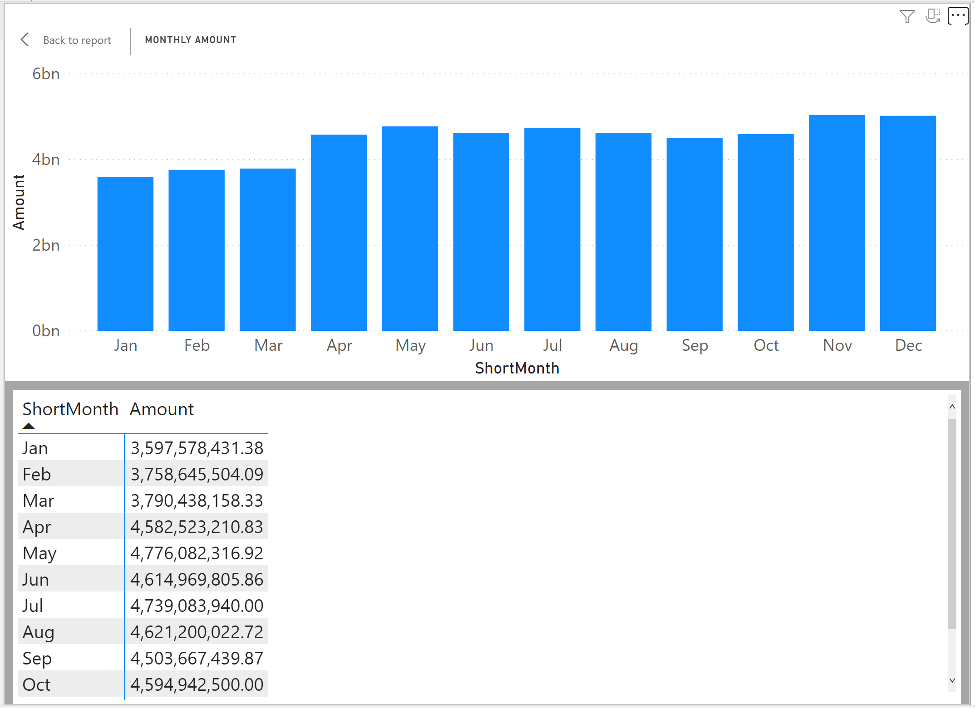

#### Creating a hierarchy - Sometimes you want to drill down into a chart and see different levels of your data. With hierarchies, you can add this functionality to your Power BI reports. Let us create a date hierarchy that looks like this: Year-Quarter-Month-Day.

#### Once you have created the hierarchy, you can drill down using the following drill controls:

* Down arrow: drill down one field at a time
* Double arrow: drill down all fields at once
* Double arrow with a line: expand all fields at once
* Navigate to the DimDate table in the *Data View*.

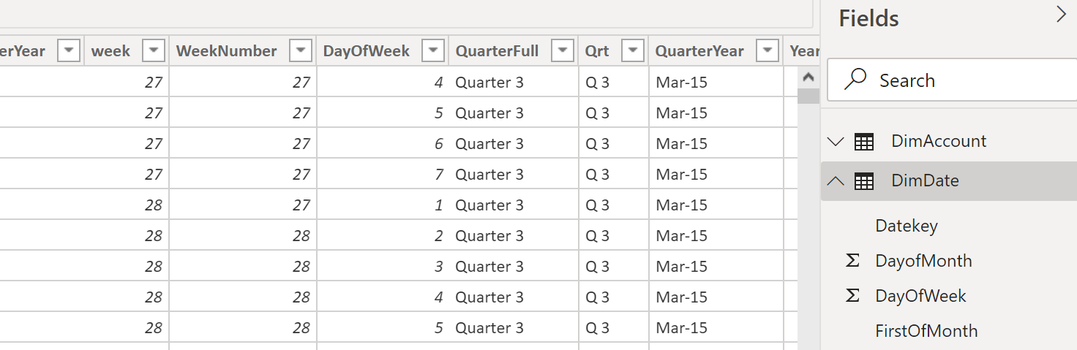



Create a hierarchy that starts with Year, goes on to the QuarterFull, then the MonthName, and ends with the DateKey.

Go to the Data view, under fields locate Year attribute of DimDate table. Click on the tilde symbol (which is More options), and select Create hierarchy.

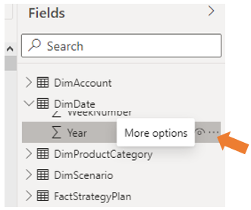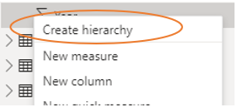

A Year Hierarchy field will be created underneath Year.



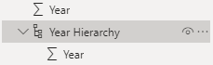

Click on the tilde (…) symbol next to the QuarterFull field, and select Add to hierarchy

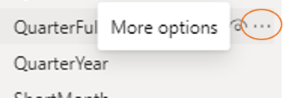 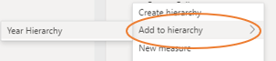

Click Year Hierarchy. A hierarchy will be created with Year and QuarterFull in it.

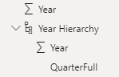

Repeat the process for MonthName. Click on the tilde (…) symbol next to the MonthName field, and select Add to hierarchy

 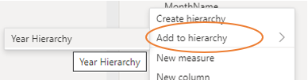

Click Year Hierarchy. The hierarchy will be modified with Year, QuarterFull, and MonthName in it.

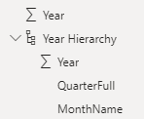

Repeat for DateKey: your final hierarchy should now look like the image below.

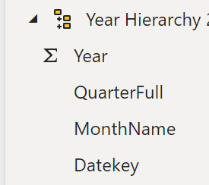



* Rename the hierarchy to Date Hierarchy. Double-click on the old hierarchy’s name and type the new one.

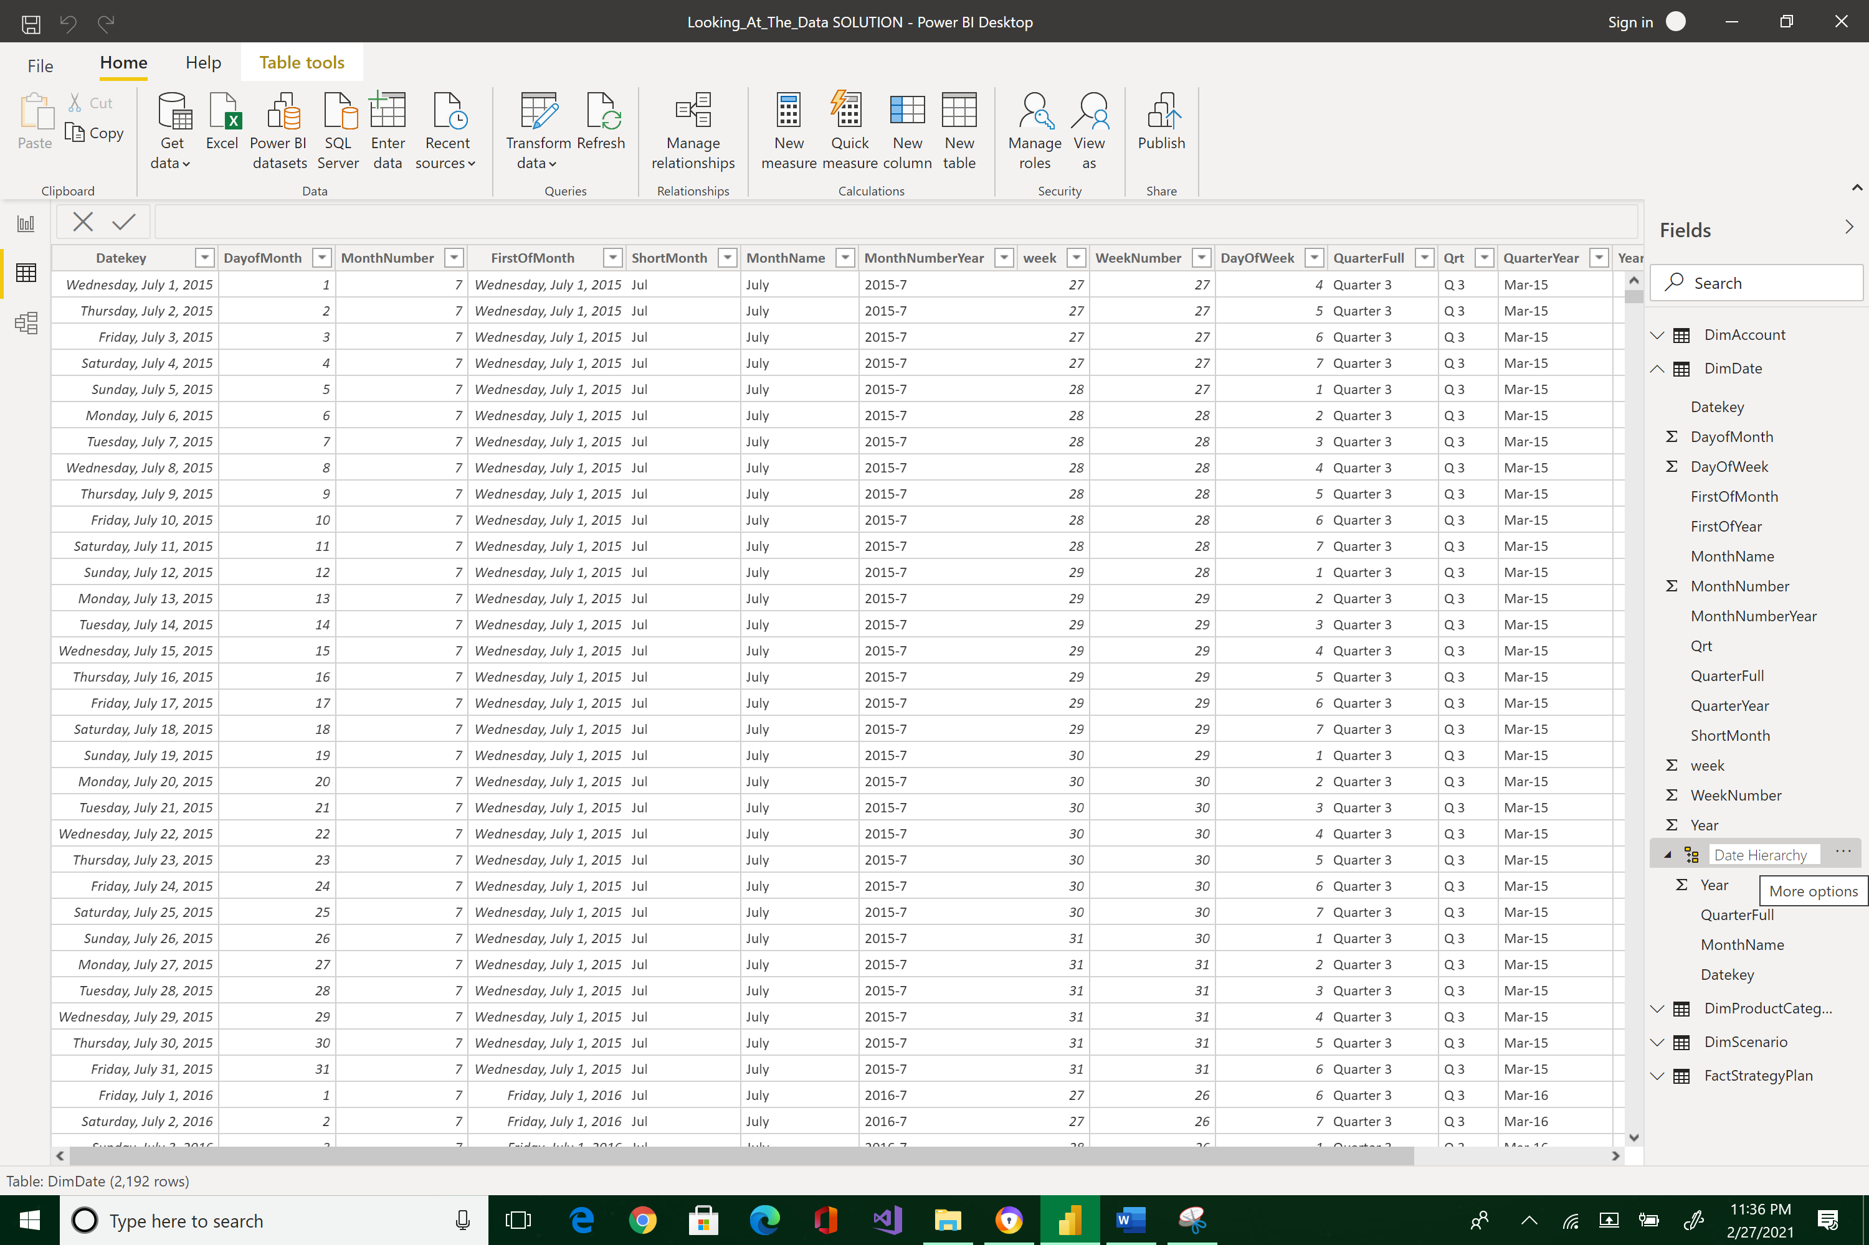

* Back to the Report view. In the "Monthly Amount" column chart, replace the ShortMonth *Axis value* of the column chart by the Date Hierarchy. Also, make sure you delete ShortMonth from the Axis pane.

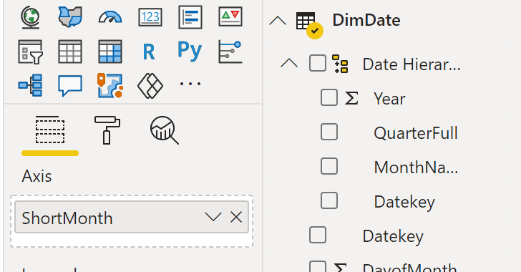



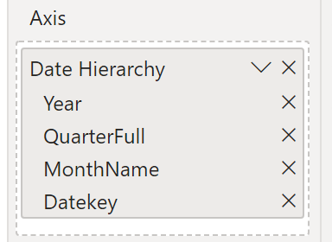

Your new Report visuals should now look like the image below:

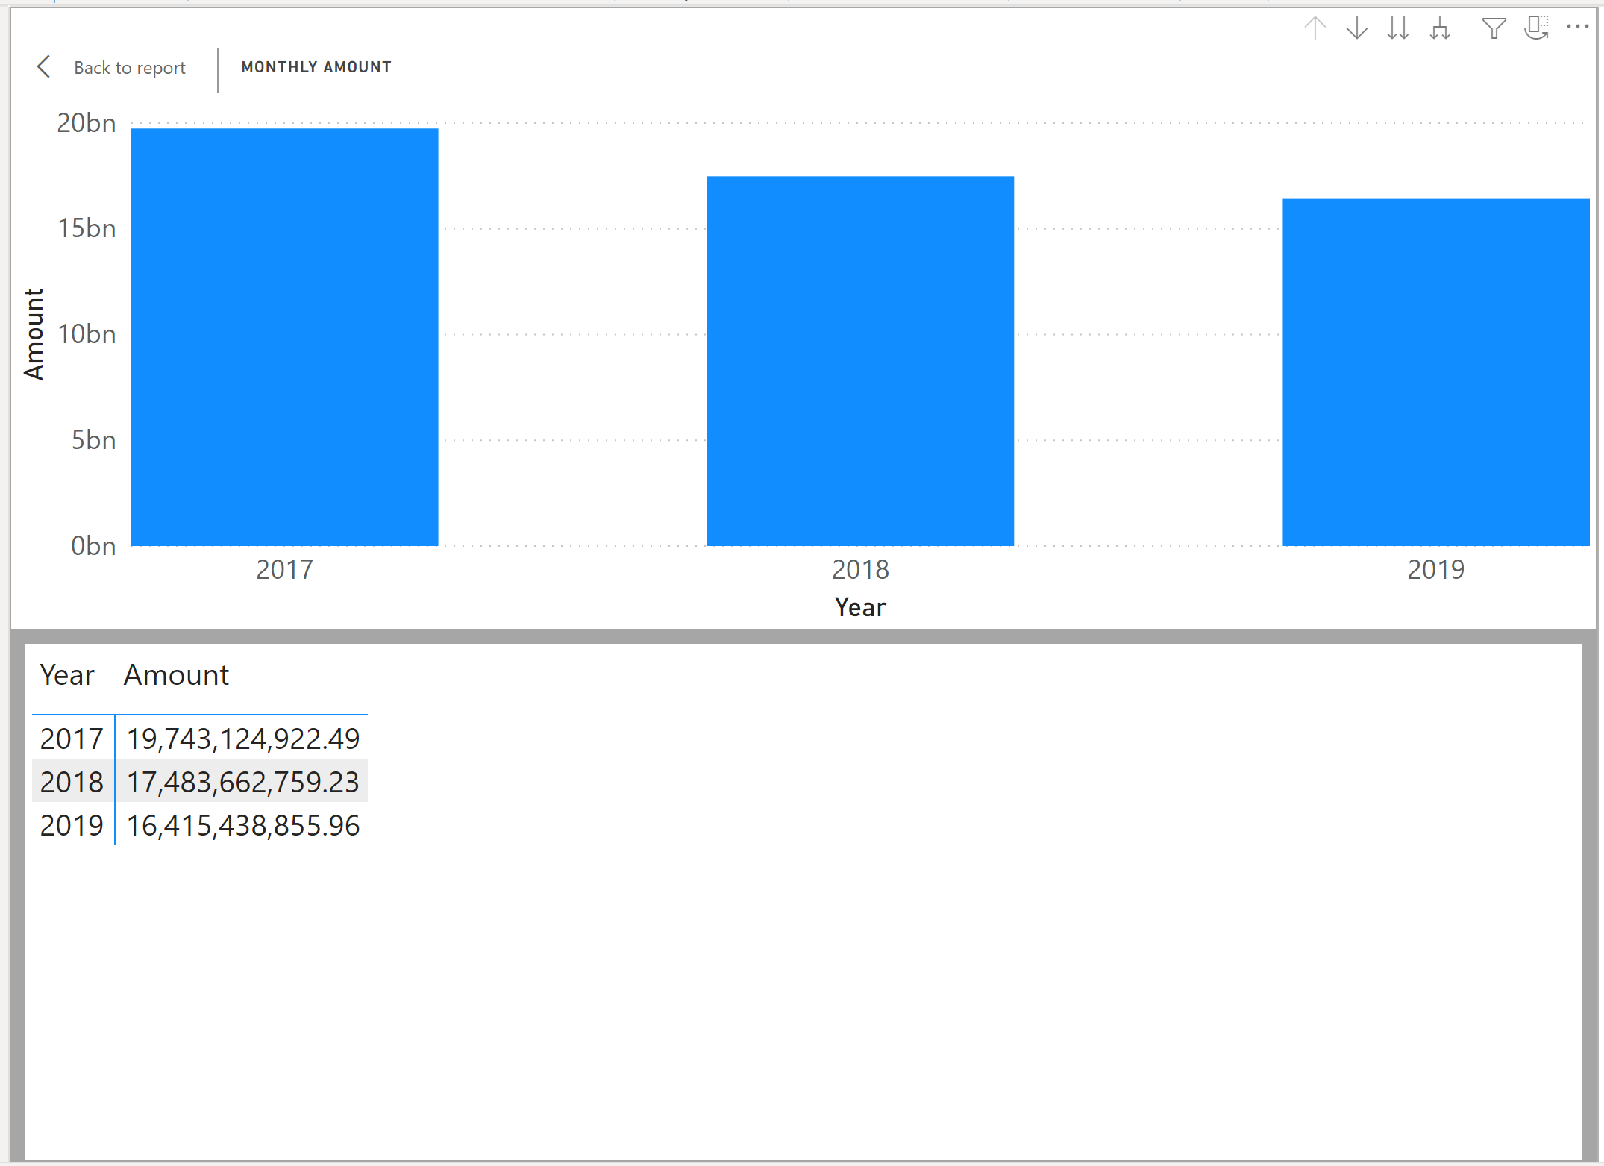



* Note the drill controls at the top-right corner of the column bar chart. Use the drill controls in the top right corner of the visual to explore the different levels. Press the single arrow-down icon 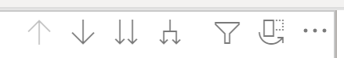



* The display will change to:

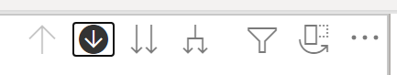



Now, press the double-arrow downs. Note how the year bars has changed to quarterly bars.

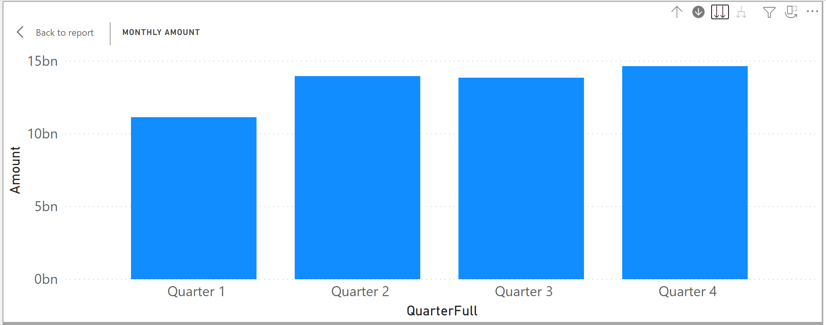



Press the double-arrows again and note how the bar shows monthly amounts.





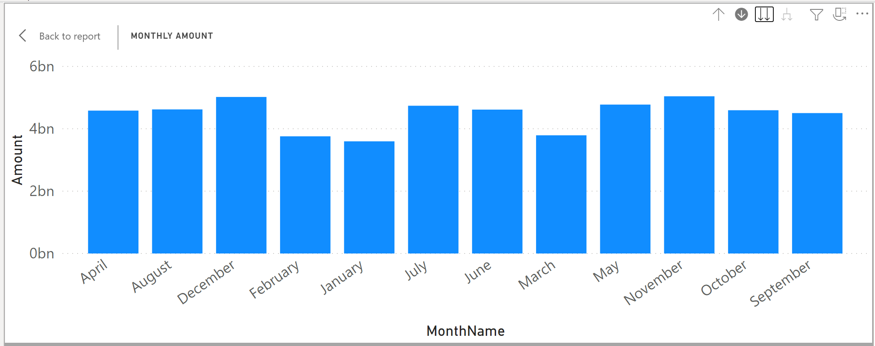

Select the double-arrow down icon one more time and watch how the display changes to DateKey.

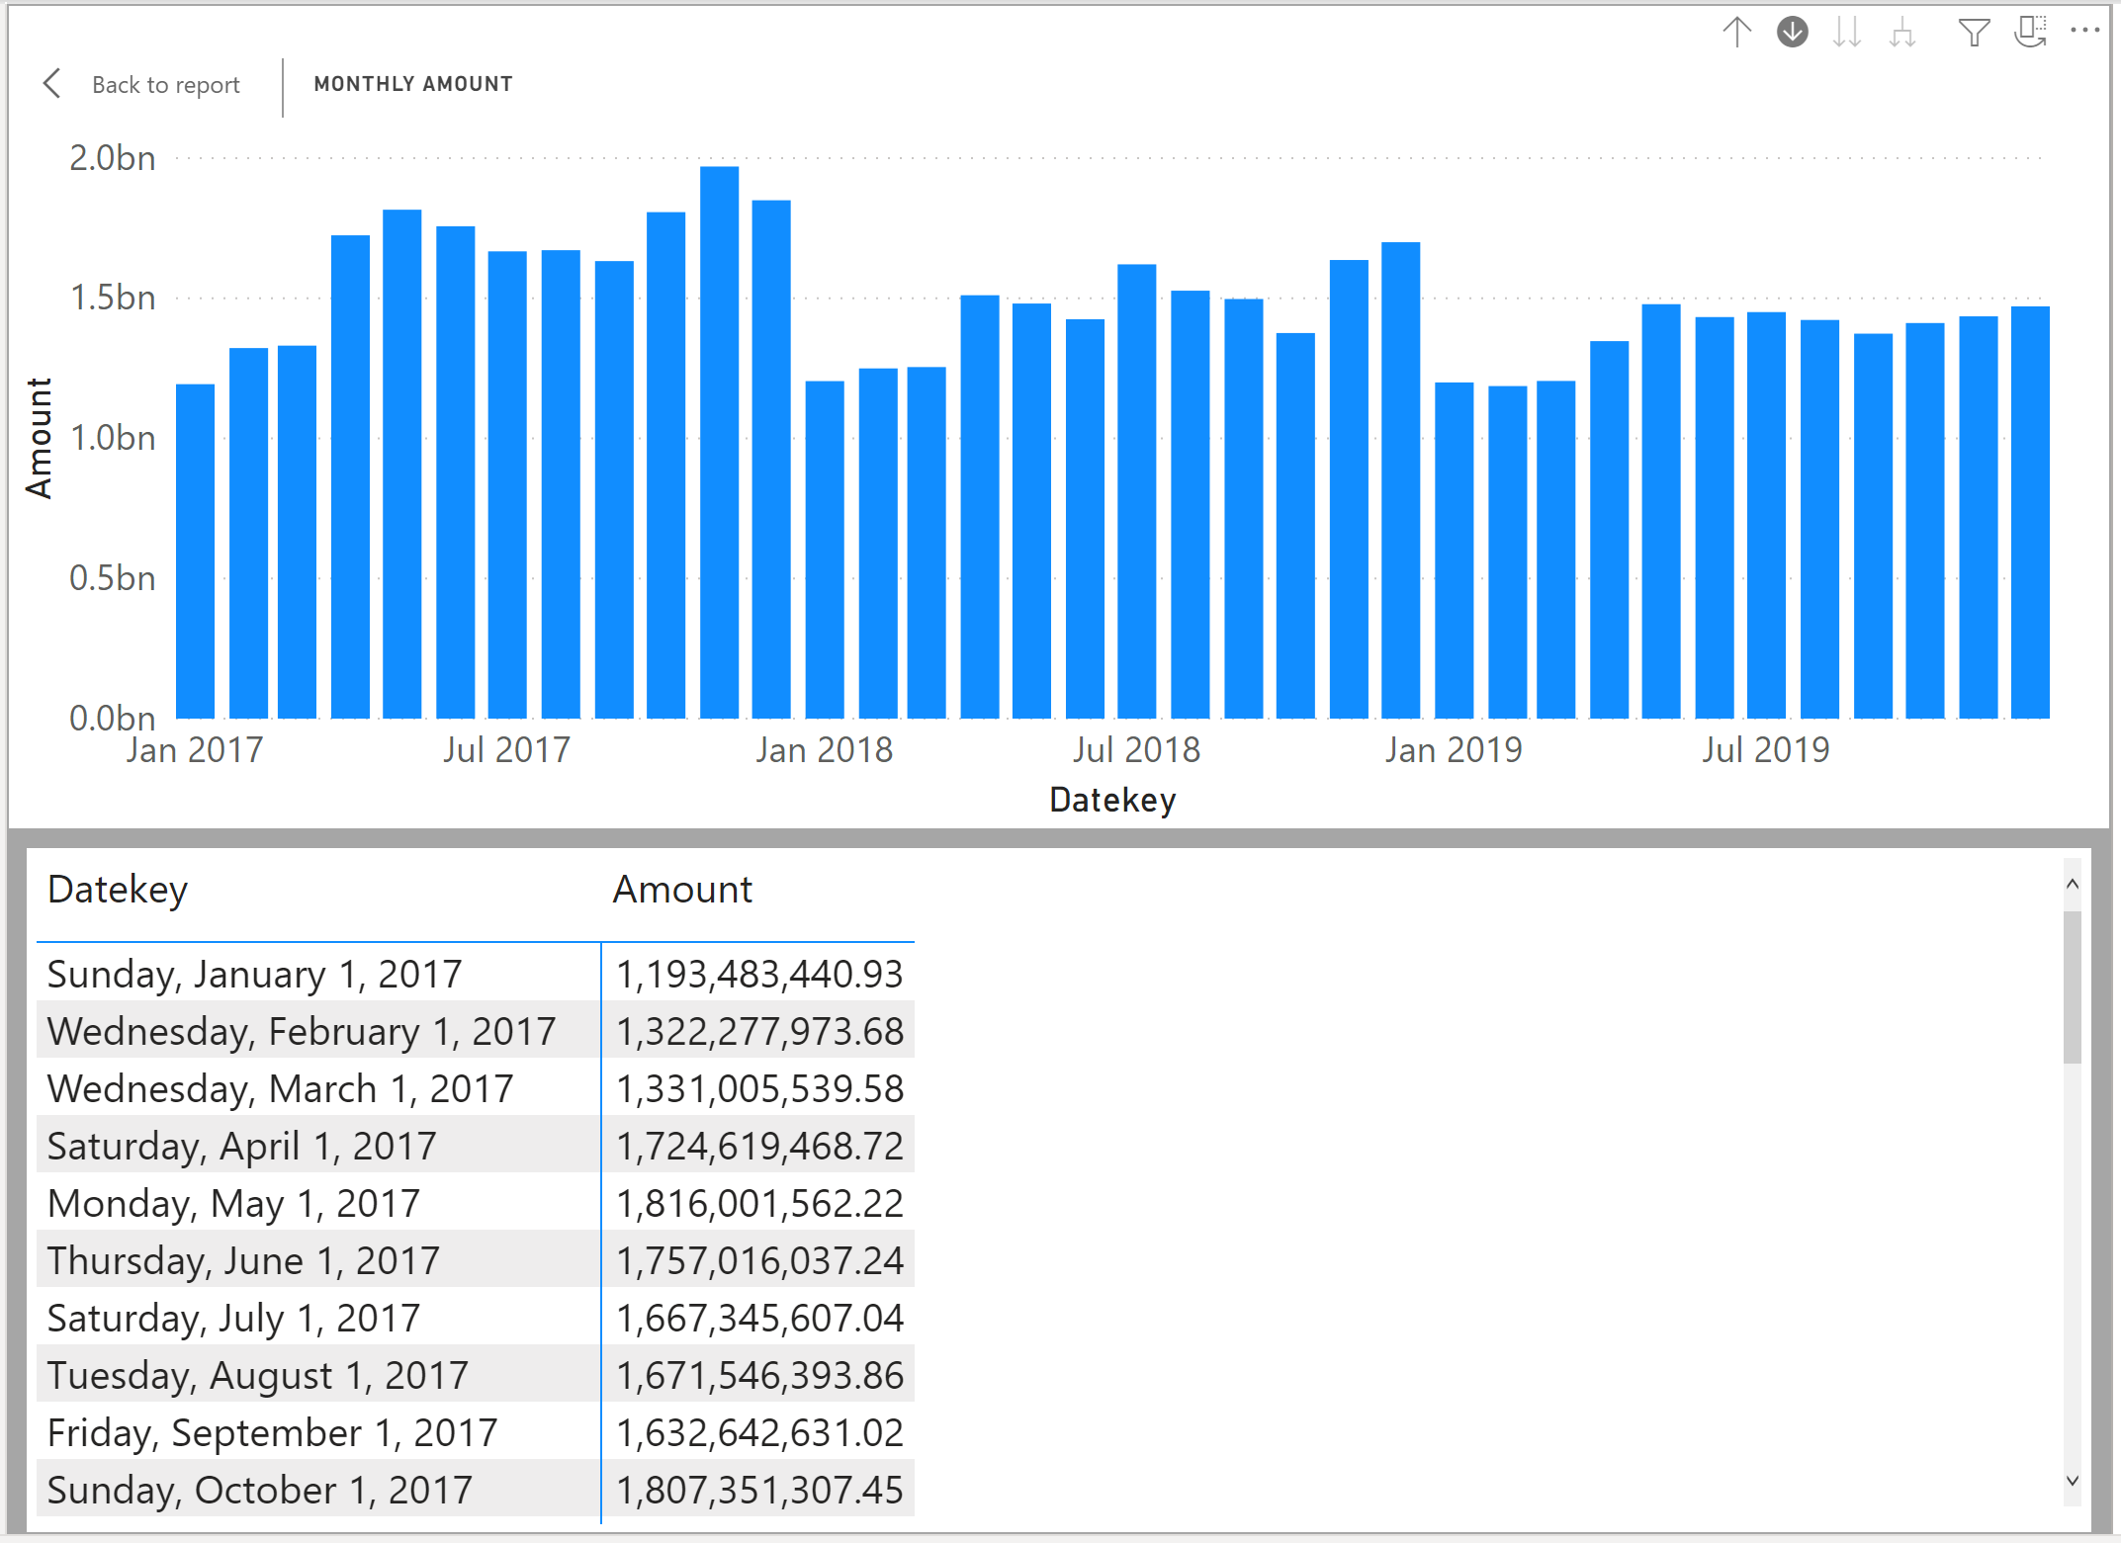



Click the single arrow-up icon twice to go back to the quarterly display.





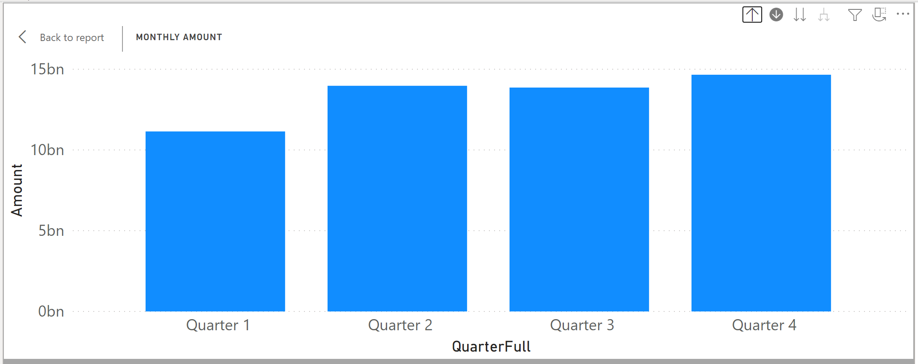



Then, press the wider-arrow-down-fork icon and observe what happens to the visualization.

You may also click on the bars to drill-down (or showing less and focused data).

Go back to the yearly display.

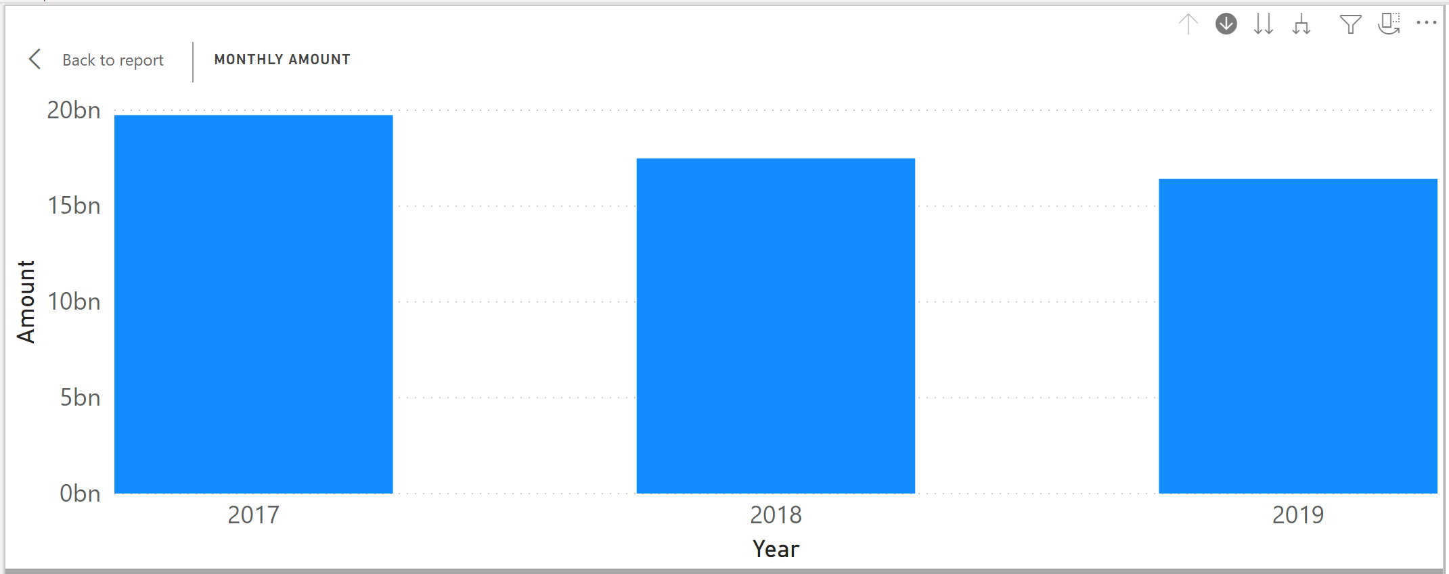



Click the fork-arrow-down

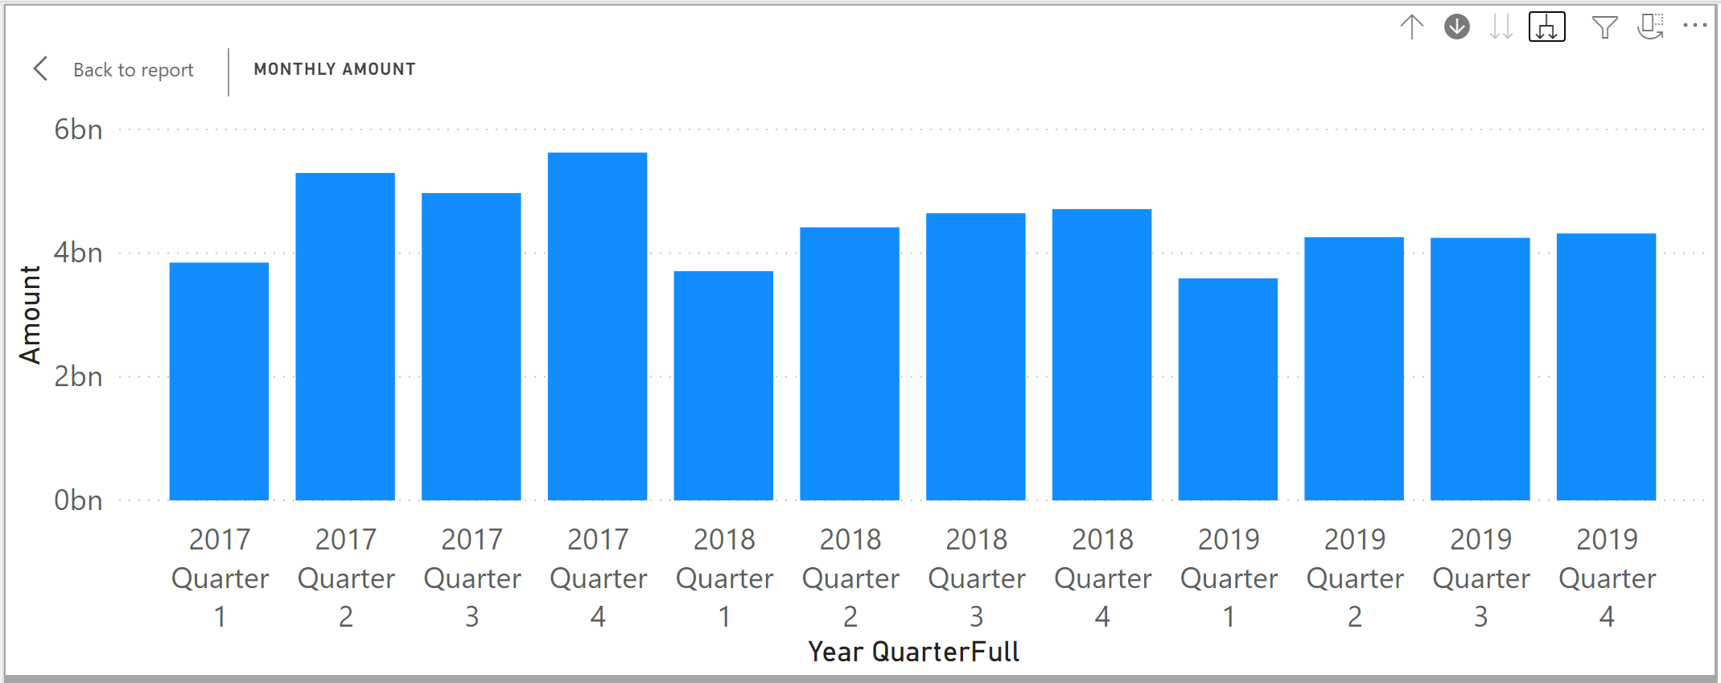



**Which quarter across all years had the highest amount (format example: Y2020 Q1)?**

|  |
| --- |
| 2017 Q4 |

Please reposition your Report so that it would look like the image below. Take a snapshot using Window's Snipping Tool. Make sure the encircled items are included. Place your image at the end of this document (after the example below) and submit this completed artifact to Canvas in Word format.  Please do not forget to save your work. Thank you!

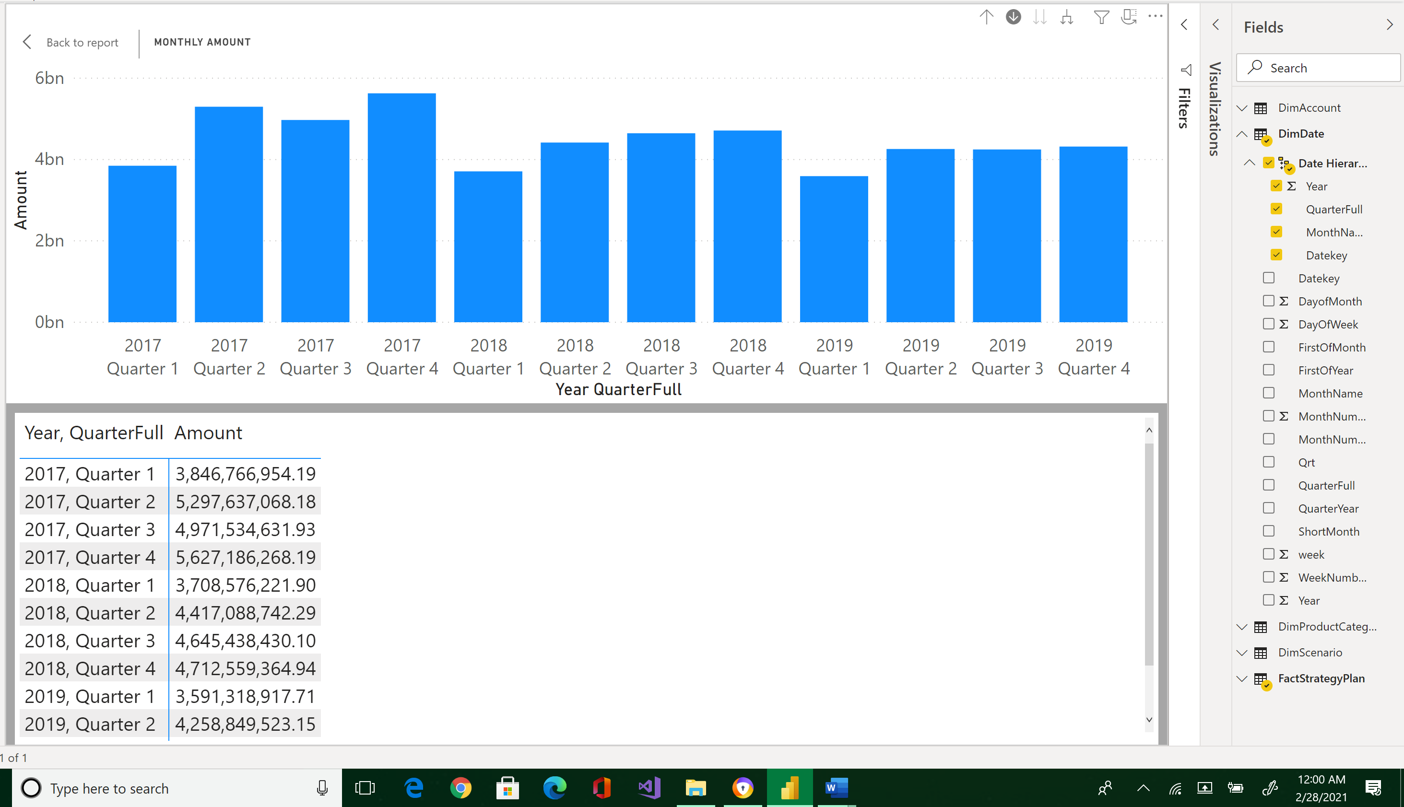



|  |
| --- |
| Please paste here your final image. |